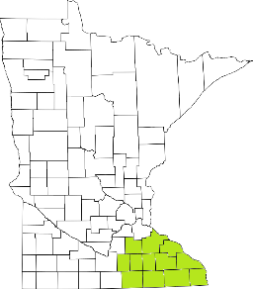Collaborative Resources Education Services Technology
(CREST)
Regional Management Team Agenda
August 12th at 1pm
1-3:00 PM
Olmsted County Community Services
SKYPE ROOM
- Welcome/Introductions
- Commitment Language (Sue Abderholden-NAMI)
- Housing Supports (Jeremy Galley-DHS)
- MH Forum Update (Tim)
- Budget (Candace)
  - Risk Assessments and Grant Management
- Other Agency Updates (All)

Next meeting scheduled for September 9th

