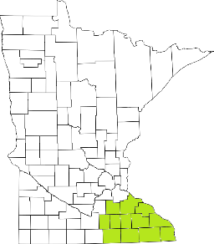Collaborative Resources Education Services Technology
(CREST)
Regional Management Team Agenda
March 11, 2020
1-3:00 PM
Olmsted County Community Services
2117 Campus Drive SE, Rochester, MN Rm 161
- Welcome/Introductions
- Meeting Minutes approval (All)
- DNMC Discussion with Dr. Ahmed (Jim P.)
- Commitment Language (Tim)
- Uniform Service Standards (Tim)
- Training Updates (All)
  - Rule 20 discussion items
- AMHI Reform discussions (Tim)
- Mental Health Awareness Month (All)
- Budget Discussion (Candace)
- Agency Updates (All)

Next meeting scheduled for April 8th

