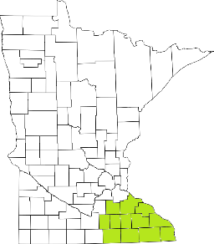Collaborative Resources Education Services Technology
(CREST)
Regional Management Team Agenda
June 8th at 1pm
1-3:00 PM
Olmsted County Community Services
SKYPE ROOM
- Welcome/Introductions
- Waivers (Tim/DHS)
- TCM reform (DHS)
- AMHI reform (Tim)
- SUD Updates (all)
- Commitment Language (Tim)
- MH residential Room and Board payments (All)
- Training Updates (Tim)
- Budget (Candace)
- Other Agency Updates (All)

Next meeting scheduled for August 12th

