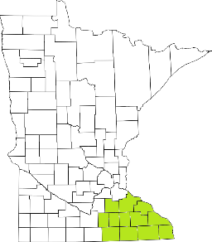Collaborative Resources Education Services Technology
(CREST)
Regional Management Team Agenda
April 8th, 2020
1-3:00 PM
Olmsted County Community Services
SKYPE ROOM
- Welcome/Introductions
- Roundtable on COVID response (All)
  - Telepresence
  - In-person protocol
  - Creative solutions
  - Stress points
  - Gaps in delivery
- AMHI increase request (Tim)
- Budgets Update (Candace)
  - COVID billing
  - AMHI budget
  - Mobile Crisis budget
- Stabilization Dollars
- Training Updates (Tim)
- DHS updates
- Other Agency Updates (All)

Next meeting scheduled for May 13th

